March 2025
 | 8 But what does it say? “The word is near you, in your mouth and in your heart” (that is, the word of faith that we proclaim); 9 because, if you confess with your mouth that Jesus is Lord and believe in your heart that God raised him from the dead, you will be saved. 10 For with the heart one believes and is justified, and with the mouth one confesses and is saved. 11 For the Scripture says, “Everyone who believes in him will not be put to shame.” 12 For there is no distinction between Jew and Greek; for the same Lord is Lord of all, bestowing his riches on all who call on him. 13 For “everyone who calls on the name of the Lord will be saved.” Romans 10:8-13 |  |  |  |  | 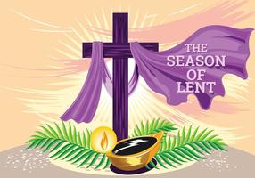
Sunday |  | Monday | Tuesday | Wednesday | Thursday |  | Friday |  | Saturday
 |  |  |  |  |  |  |  |  | 1
Altar Guild:
Lynn Moulds

2 |  | 3 | 4 | 5 | 6 |  |  | 7 | 8
THE TRANSFIGURATION OF OUR LORD  Bible Stud 10:15 am  Sun. School10:15am  Worship 11:15 am  Acolyte – Victor |  |  | SHROVE TUESDAY  PANCAKES  6:30 PM | ASH WEDNESDAY  7pm |  |  |  |  | LADIES OF GRACE @ 9:30 AM
9 |  | 10 | 11 | 12 | 13 |  |  | 14 | 15
1ST Sunday in Lent  Bible Stud 10:15 am  Sun. School10:15am  Worship 11:15 am  Acolyte – Christine |  |  | Quilting 9:30 am | MIDWEEK LENT SERVICES @ 7:00 PM
16 |  | 17 | 18 | 19 | 20 |  |  | 21 | 22
2nd Sunday in Lent  Bible Stud 10:15 am  Sun. School10:15am  Worship 11:15 am  Acolyte – Nathan |  |  | Quilting 9:30 am | MIDWEEK LENT SERVICES @ 7:00 PM | First day of Spring,
23 |  | 24 | 25 | 26 | 27 |  |  | 28 | 29
3rd Sunday in Lent  Bible Stud 10:15 am  Sun. School10:15am  Worship 11:15 am  Acolyte –Victor |  |  | Quilting 9:30 am | MIDWEEK LENT SERVICES @ 7:00 PM
30 |  | 31 |  | APRIL 2 | Dates to remember
4th Sunday in Lent  Bible Stud 10:15 am  Sun. School10:15am  Worship 11:15 am  Acolyte – Christine |  |  |  | MIDWEEK LENT SERVICES @ 7:00 PM | Apr 6 -5th Sun. in lent  4.13 Palm Sun.  4.16 – NO MIDWEEK  4.17-Maunday thurs.  4.18-Good Friday  4.19- Holy Saturday  April 20 -EASTER ! |  |  | 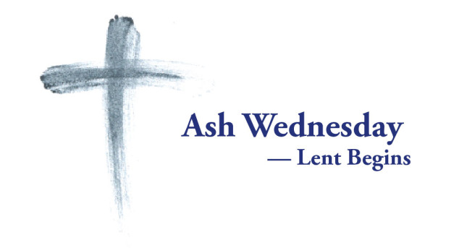  This Photo by Unknown Author is licensed under CC BY-SA-NC

