January 2024
The Baptism  At that time Jesus came from Nazareth in Galilee and was baptized by John in the Jordan. ^{1J}ust as Jesus was coming up out of the water, he saw heaven being torn open and the Spirit descending on him like a dove. And a voice came from heaven: “You are my Son, whom I love; with you I am well pleased.” Mark 1: 9-11  Altar: Kathy Galloway | 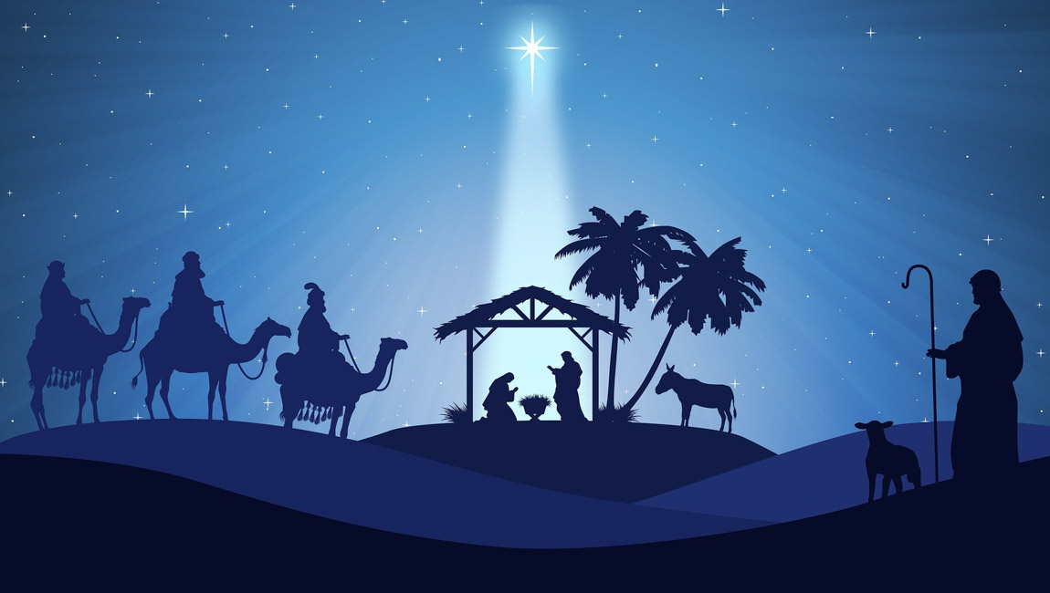
Sunday | Monday | Tuesday | Wednesday | Thursday | Friday | Saturday
 | 1 | 2 | 3 | 4 | 5 | 6
 | Feast of the Circumcision and name of Jesus. Happy New Year! |  |  |  |  | Epiphany Service; Christ Our King,  +Mississauga 7pm
7 | 8 | 9 | 10 | 11 | 12 | 13
Baptism of our Lord Ss @ 9:30 am  Bible Study @9:30 am  Worship Service 10:30 am  Acolyte: Christine |  | Noon – Toronto Pastor’s Winkel | BIBLE STUDY 9:30 AM |  |  | Ladies of Grace 9:30 am Bible Study with Pastor
14 | 15 | 16 | 17 | 18 | 19 | 20
2nd Sunday After the Epiphany  Ss @ 9:30 am  Bible Study @9:30 am  Worship Service 10:30 am  Acolyte: Victor |  |  | BIBLE STUDY 9:30 AM | The confession of St. Paul
21 | 22 | 23 | 24 | 25 | 26 | 27
3rd Sunday After the Epiphany  Ss @ 9:30 am  Bible Study @9:30 am  Worship Service 10:30 am  Acolyte: Victor |  |  | BIBLE STUDY 9:30 AM | The Conversion of St Paul | St. Titus, Pastor & Confessor | Justin & Grace dilts, wedding blessing, Fort Wayne, IN
28 | 29 | 30 | 31
4th Sunday After the Epiphany  Ss @ 9:30 am  Bible Study @9:30 am  Worship Servie10:30 am  Acolyte: Nathan |  |  | BIBLE STUDY 9:30 AM
Happy New Year!!!

