September 2023
Back to School and Sunday School (ss) begins on Sept 10th, 2023  “For the kingdom of heaven is like a landowner who went out early in the morning to hire workers for his.” | 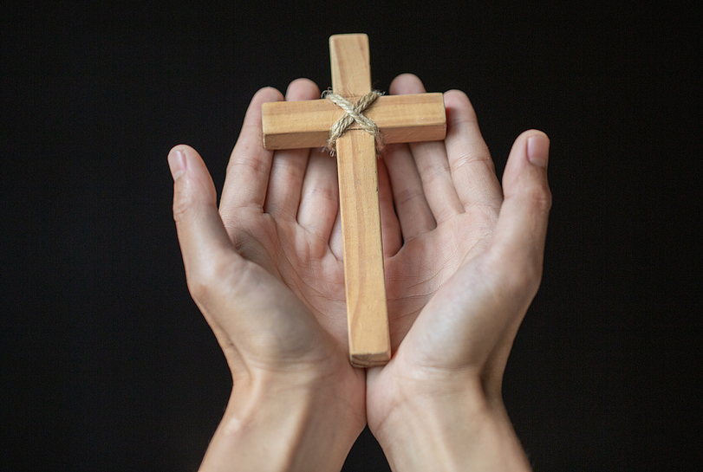
Sunday | Monday | Tuesday | Wednesday | Thursday | Friday | Saturday
 |  |  |  |  | 1 | 2
3 | 4 | 5 | 6 | 7 | 8 | 9
 | Labour Day | Back to school for the kids |  |  |  | Ladies of Grace Kitchen cleaning day. More dates to come.
10 | 11 | 12 | 13 | 14 | 15 | 16
14th Sunday after Pentecost  Ss @ 9:30 am  Bible Study @9:30 am  Worship Service 10:30 am  Acolyte: Nathan |  | 9 am Quilting  10 am Winkel St Matthew, Scarborough | Bible study @ 9:30am | HOLY CROSS
17 | 18 | 19 | 20 | 21 | 22 | 23
15th Sunday after Pentecost  Ss @ 9:30 am  Bible Study @9:30 am  Worship Service 10:30 am  Acolyte: Victor |  | Elder’s Meeting 7pm | Bible study @ 9:30am
24 | 25 | 26 | 27 | 28 | 29 | 30
16th Sunday after Pentecost  Ss @ 9:30 am  Bible Study @9:30 am  Worship Service 10:30 am  Acolyte: victor |  |  | Bible study @ 9:30am |  | St Michael  & All Angels

