October 2023
Give thanks to the LORD, for he is good; his love endures forever. Psalm 118 :1  Altar Guild: Julia Booroff | 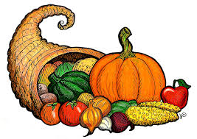
Sunday | Monday | Tuesday | Wednesday | Thursday | Friday | Saturday
1 | 2 | 3 | 4 | 5 | 6 | 7
17th Sunday after Pentecost; LWML  Ss @ 9:30 am  Bible Study @9:30 am  Worship Service 10:30 am  Kingston Mission 4pm  Acolyte-Christine | Pastors’ Conference Niagara Falls | Quilting 9 am  Pastors’ Conference Niagara Falls | Pastors’ Conference Niagara Falls |  |  | Ladies of Grace 9:30 am
8 | 9 | 10 | 11 | 12 | 13 | 14
18th Sunday after Pentecost  Ss @ 9:30 am  Bible Study @9:30 am  Worship Service 10:30 am  Acolyte: Victor | Happy Thanksgiving!!!  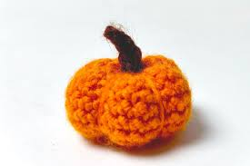 | Quilting 9 am | Bible study @ 9:30am  Council Meeting 7:30 pm |  |  | Ladies of Grace retreat Cambridge
15 | 16 | 17 | 18 | 19 | 20 | 21
19th Sunday after Pentecost  Ss @ 9:30 am  Bible Study @9:30 am  Worship Service 10:30 am  Acolyte: Nathan |  | Quilting 9 am | Bible study @ 9:30am |  |  | Council Retreat
22 | 23 | 24 | 25 | 26 | 27 | 28
20th Sunday after Pentecost  Ss @ 9:30 am  Bible Study @9:30 am  Worship Service 10:30 am  Acolyte Nathan |  | Quilting 9 am | Bible study @ 9:30am  St Luke, Evangelist
29 | 30 | 31
21th Sunday after Pentecost  Ss @ 9:30 am  Bible Study @9:30 am  Worship Service 10:30 am  Acolyte: Christine |  | Quilting 9 am  Reformation Day!
Voter’s Meeting October 29th, 2023 after Service

